Repetition of results

Figure 1 and 3 from the main article were generated by PromKappa program while the remaining figures were generated in Excel using data provided by PromNN neural network program. Promoter patterns have been converted from BMP (Bitmap Image File) format (file format in which they were originally generated by PromKappa) to JPG (Joint Photographic Experts Group) format for reasons of space. For instance, promoter patterns generated in BMP format can reach up to 2-3 Gb while a JPG conversion reduces the size of these files to 50-100Mb. For this reduction in file size any BMP-JPG conversion program can be used (we have used ACDSee). PromNN recognizes black/white promoter patterns in JPG format. Promoter patterns (black/white) generated with PromKappa can be found in Supplementary Material 11 and 12. A promoter sequence can be loaded into the program by using Copy/Paste (Fig. 1j). However, PromKappa can also test a large list of promoters automatically.
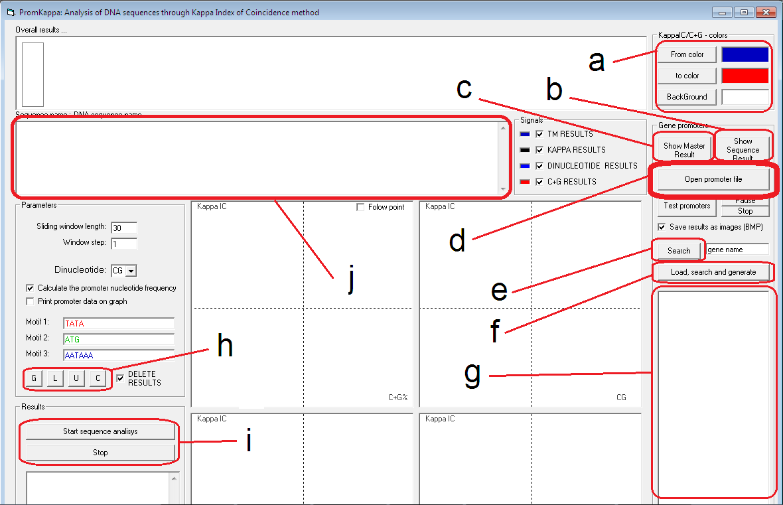
Figure 1 PromKappa. (a) background and pattern color, (b) promoter pattern Tab, (c) promoter pattern distribution Tab (d) file loading, (e) gene name search, (f) automatic searching of gene names in the promoter list, (g) promoter sequence container, (i) manual analysis of a single promoter sequence, (h) buttons for promoter sequence editing (G-random sequence generation, L-lowercase U-uppercase, C-sequence filtering of carriage return (CR) and line feed (LF) characters), (j) text box containing the promoter sequence for immediate analysis.

Step 1:
Run “PromKappa.exe” file (or open CG.vbp file from Visual Basic 6 programming language).

Step 2:
Press "Open promoter file" button (Fig. 1d) and select one of the files containing promoter sequences from Supplementary Material 8.

Step 3:
Change pattern color to black (Fig. 1a).

Step 4:
Press "Test promoters" button. Each promoter pattern is saved in the “chart” local folder as a BMP file. For 20,586 promoter sequences this step may take between 3 and 4 hours.

Step 5:
Convert each BMP file to JPG files and store them in the same folder.

Step 6:
Run “PromNN.exe” file.
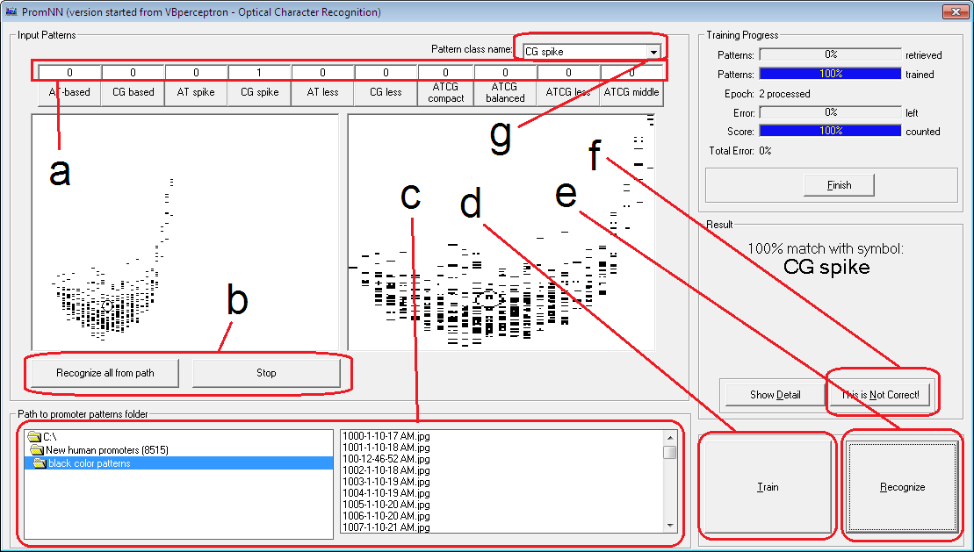
Figure 2 PromNN. (a) the number of promoters found for each class, (b) automatic recognition of all promoter patterns contained in a folder, (c) path navigation to the folder containing the promoter patterns generated by PromKappa (d) neural network pattern learning, (e) neural network recognition verification, (f) neural network reinforcement of pattern recognition in case of error, (g) promoter class name.

Step 7:
Navigate to “chart” folder path where the promoter patterns are stored (Fig. 2c).

Step 8:
Train the neural network to recognize each promoter class. Before starting the learning process for a certain class, press the button corresponding to that class. Promoter patterns can be selected at random from the file list (Fig. 2c) and can be associated with certain classes of promoters depending on their shape and density. Promoter patterns from our Supplementary Material 10 can also be used for training. When a pattern is associated with a certain promoter class, make sure it resembles one of the patterns illustrated in Figure 3a-j.
Figure 3 Promoter patterns models. (a) AT-based, (b) CG-based, (c) ATCG-compact, (d) ATCG-balanced, (e) ATCG-middle, (f) ATCG-less, (g) AT-less, (h) CG-spike, (i) CG-less and (j) AT-spike. Pink areas show denser clusters whereas light grayish gold color shows lower density clusters.

Step 9:
Press "Recognize all from path" button (Fig. 2b). For 20,586 promoter patterns this step may take between 6 and 8 hours.
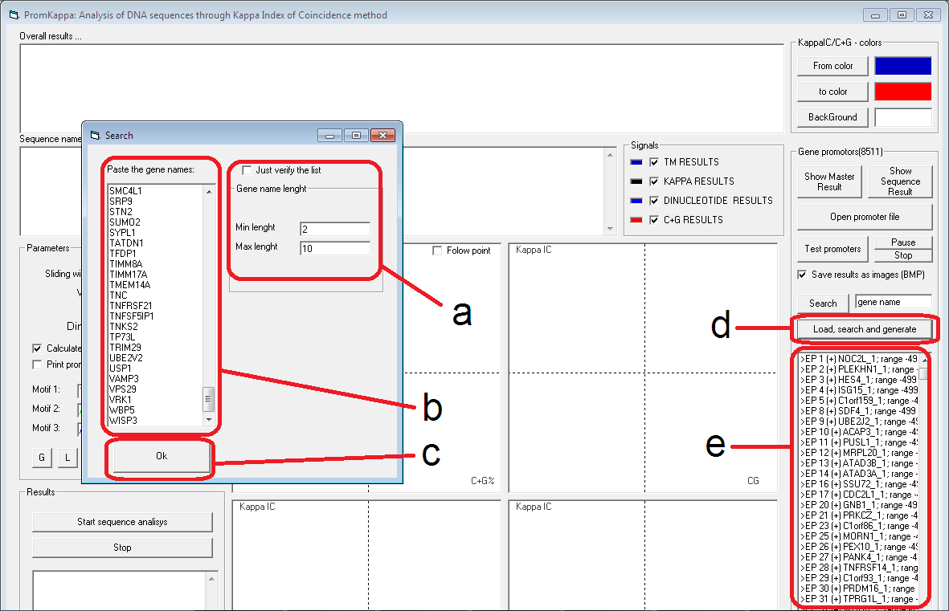
Figure 4 Automatic search of promoters by using lists of gene names. (a) minimum and maximum number of characters for the gene name, (b) list of gene names, (c) the button that starts the search process, (d) the button that opens the search window, (e) promoter sequence container.

Step 10:
Copy the results from the text boxes (Fig. 2a) for each class of promoters for further processing.

We also show an automatic search of promoters by using lists of gene names (Fig. 4). The significance of these promoter patterns and their distribution is explained in Figure 5 and 6. PromNN sorted patterns are stored automatically in the “sort” folder (in PromNN current application folder).
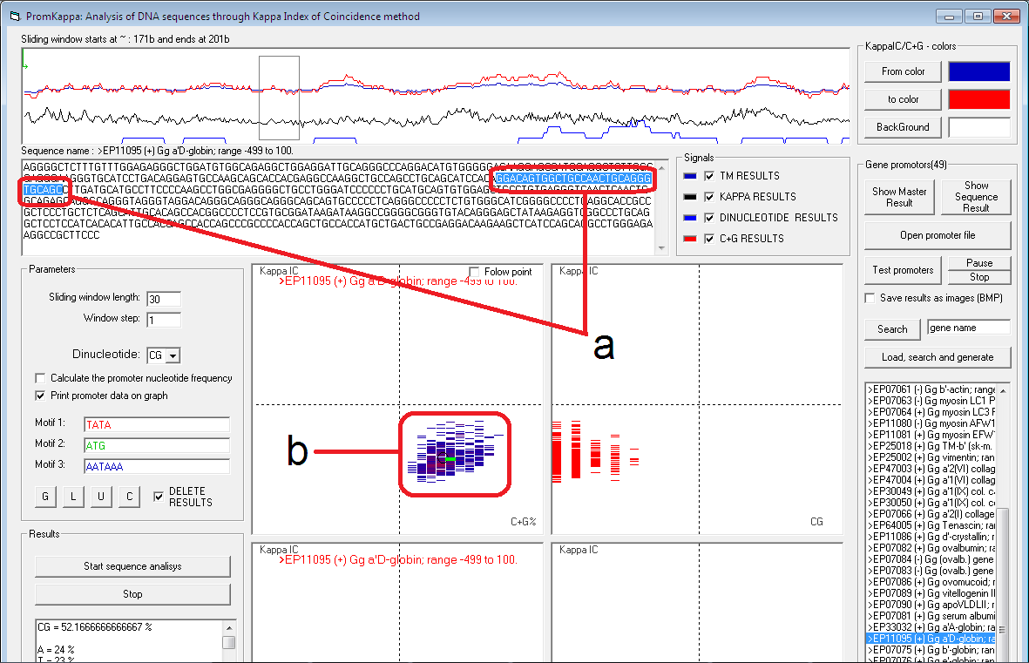
Figure 5 Relationship between the shape of the promoter pattern and different structures such as Simple Sequence Repeats (SSRs) or short tandem repeats (STRs). (a) the sliding window, (b) green line in the middle of the pattern reflects the sliding window position and the local characteristics of the promoter sequence.

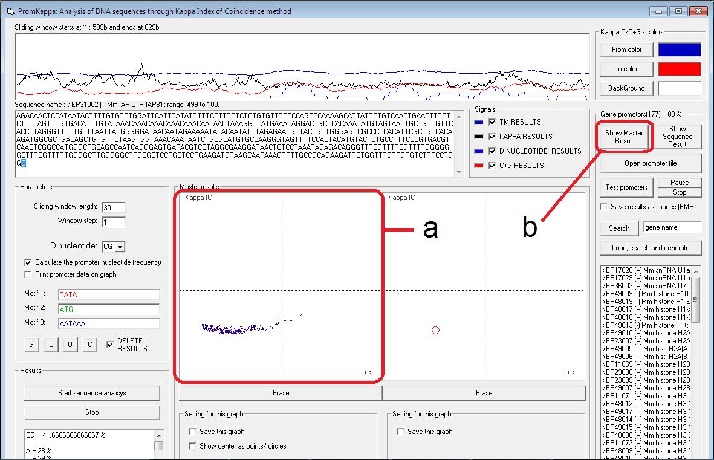
Figure 6 Distribution of promoters in Mus Musculus. (a) each circle represents the center of weight from a promoter pattern, (b) on click, the button is showing the promoter pattern distribution Tab.

